**PICNIC**

**#WORLD**

**REFUGEE**

**DAY**

**SATURDAY,**

**JUNE 18**

**PM**

**1-4**

Guests are invited (but not required) to

**Bring a favorite dish to share**

**EDGEWATER PARK**

KITE FIELD

**Join Us for a Day of Family Fun**

as we celebrate our newest neighbors

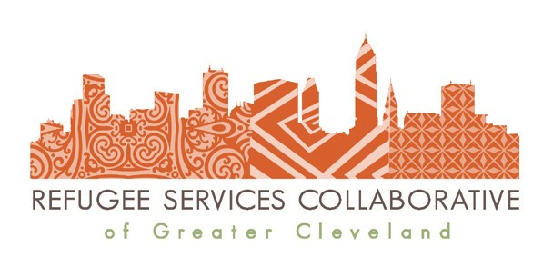

**Kids Games & Much More!**

*With Support from*

**RSC**

**Cleveland.org**

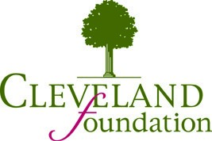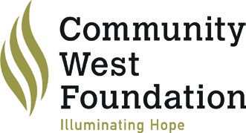

Asian Services In Action, Building Hope in the City, Cleveland Heights - University Heights School District, Cleveland Metropolitan

School District, Cuyahoga County Dept. of Job & Family Services, El Barrio: The Centers for Families & Children, Lakewood City Schools,

Neighborhood Family Practice, Ohio Department of Job & Family Services: Refugee Services, Tri-C ABLE, The Refugee Response

